presents
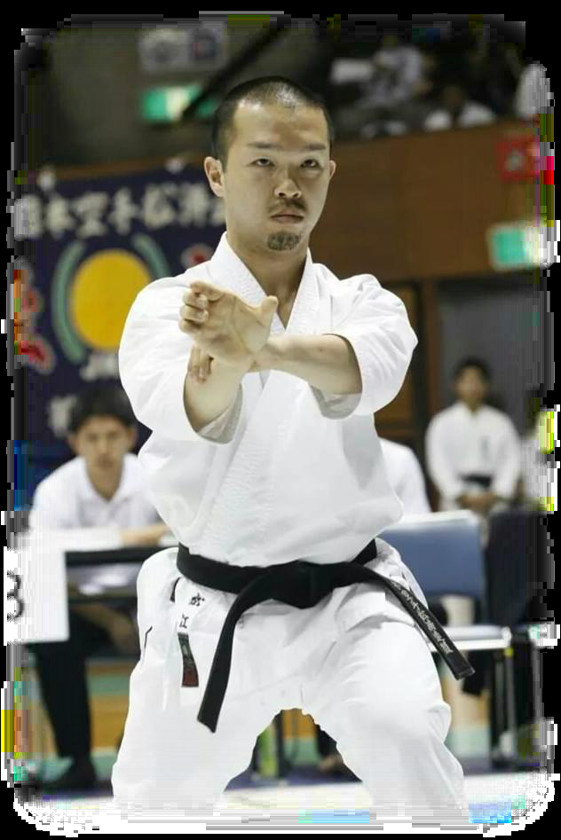
Matsue Sensei
JKS Honbu Dojo instructor
Monday 9th October 17
6.15 – 7.20 - pm
7.25 - 8.30pm

1 session £15
2 sessions £20

Train with one of the best instructors around today. Contact us now!

JKS Edinburgh Dojo, King’s Church
Gilmore Place, Edinburgh

Each session will be limited in numbers so please book in advance to avoid disappointment!!

Name: ................................................................................ Date: .............................. Fee Received: …………………………………

Application – Matsue Sensei – Edinburgh Dojo Course 9th October 2017

Name: ................................................................... Age: ……………. Grade: ……………….Club: …….………………………………..

Address: ................................................................................................................... Post Code: ………………………

Courses attending: Friday 6.15pm 7.20pm Paid: ………………………………..

Declaration & Form of Release: I hereby declare that I am physically and mentally fit to participate in this course. I indemnify the organisers and officials of the said course
In respect of any negligence, loss, injury, or damage caused. I fully understand that Karate is a high risk sport and injury is a foreseeable consequence whilst participating in
this event.

Student Sign: ............................................................. Date: .................................................................
Parent (If under 16 yrs)
Full Details available at www.jksscotland.com or Telephone Robert on 07872958814, Email jksedinburgh@sky.com
Japan Karate Shotorenmei – Scotland, Honbu Dojo, 24 Dickson Street, Elgin Ind’ Estate, Dunfermline, KY12 7SN

